|  |
| --- |
|  |
| **Project Title**  **Test Plan**  **Cohort: A**  **Group: 1**  **Group members:**  **ABC 123 (Team leader)**  **XYZ 456** |
|  |

|  |
| --- |
|  |

Document Acceptance and Release Notice

This document is authorised for release once all signatures have been obtained.

|  |  |  |  |  |  |  |  |
| --- | --- | --- | --- | --- | --- | --- | --- |
| PREPARED: |  | Date: |  | / |  | / |  |
| (for acceptance) | <Name>  Project Manager, Student Group |  |  | | | | |
|  |  |  |  | | | | |
| ACCEPTED: |  | Date: |  | / |  | / |  |
| (for release) | Project Sponsor, VIT |  |  | | | | |

**Table of Contents**

1. Introduction 1

1.2 Scope 1

1.3 Quality Objective 1

1.4 Roles and Responsibilities 1

2 Test Methodology 1

2.1 Overview 1

2.2 Test Levels 1

2.3 Test Completeness 2

3 Test Deliverables 2

3.1 Overview 2

3.2 Test Cases 2

4 Resources and Environment Needs 2

4.1 Testing Tools 2

4.2 Test Cases 2

5 References 3

**List of Figures**

Fig 1. 1 My lecturer. 1

Fig 3. 1 Testing strategy diagram. 2

**List of Tables**

Table 3. 1 Test Case table. 2

**Glossary**

|  |  |
| --- | --- |
| **API** | Application Program Interface |
| **AUT** | Application Under Test |
|  |  |

# Introduction

We will first gather the requirements from requirement document then we will first analyse the requirements and plan the testing strategies accordingly. The QA Analyst of our team will ensure that the software meets the needs of stakeholders. We will first test the website in functions called functional testing. After functional testing and unit testing when we realize that the software meets its requirements then we will move towards integration testing i-e the testing of the whole system. The developer of our testing team will remove the bugs timely when arrived. We used the **iterative Model of testing.**

## Scope

The requirements of the project that will be tested are following:

* Sellers can Add property to the website with the details like image, video, demand, description, no of rooms etc.
* Sellers can register themselves as well as login to the system.
* Seller can chat with the buyer, if buyer asks something.
* Seller can check the property of his owns.
* Seller can check offers to his property.
* Seller can approve one offer.
* Seller can contact admin before registration for ay query. Reply will be given through email.
* Buyer can search the property
* Buyer can view the property details like image, video and all the description, demand etc.
* Buyer can contact admin before registration for any query. Reply will be given through email.
* Buyer can make offer to any property.
* Admin can register another admin.
* Admin can view and delete the property.
* Admin can delete and view the user.

The requirements of the project that will not be tested are following:

* Admin can communicate the buyer after approval of the offer.
* Buyer will be notified by email if his offer approves.

## Quality Objective

Some objectives of testing the project could be

* The website meets the needs of the users and stakeholders.
* The website must be free from bugs and runtime errors.
* The website will be responsive to all devices.

## Roles and Responsibilities

Since as already mentioned that we are using iterative testing model so every person in our group has done the testing of their own work and parts. **Mr Nazeemullah Khan** is the QA Analyst and **Ashoke Thapa** is the testing manager. **Mr Atif Fazal and Mr Abbas** are testing configuration managers. **Mr Furqan Jaffer** is the Testing Team Lead.

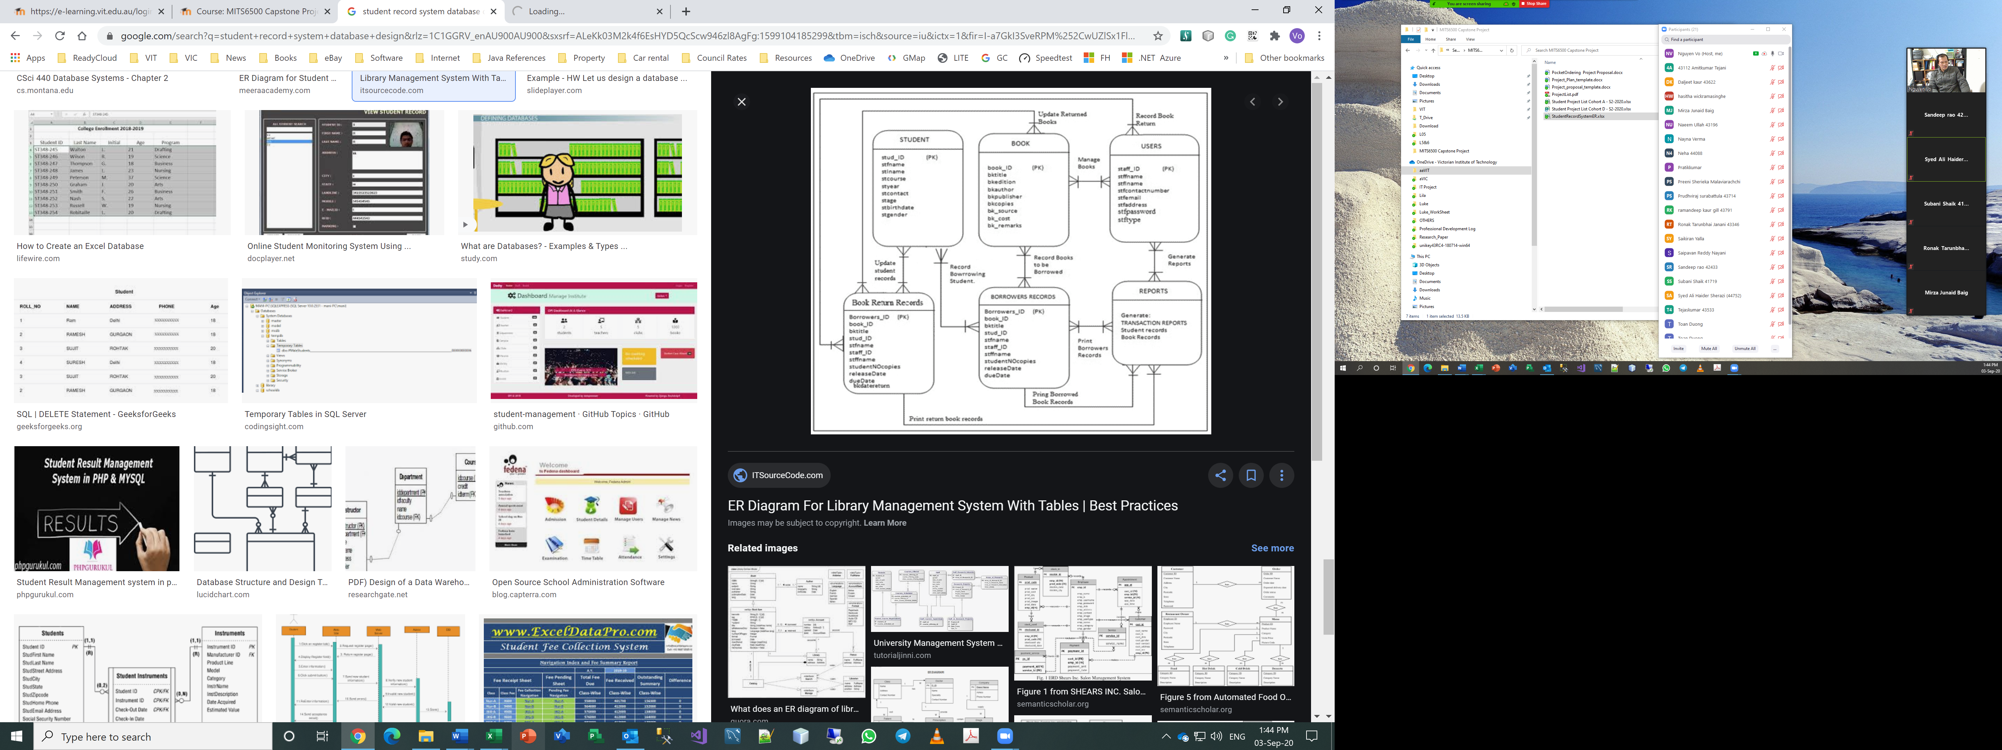

Fig 1. My lecturer.

# Test Methodology

## Overview

As we mentioned before that we used iterative testing model so we choose this in the beginning because in iterative testing model the testing carry on during development and when one feature launches in the market then it will be free from bugs. It saves our lots of time and provides efficiency to our project.

## Test Levels

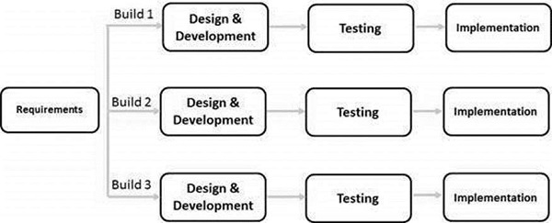

Fig 3. 1 Testing strategy diagram.

## Test Completeness

* Test case 001 (testing contact us form)

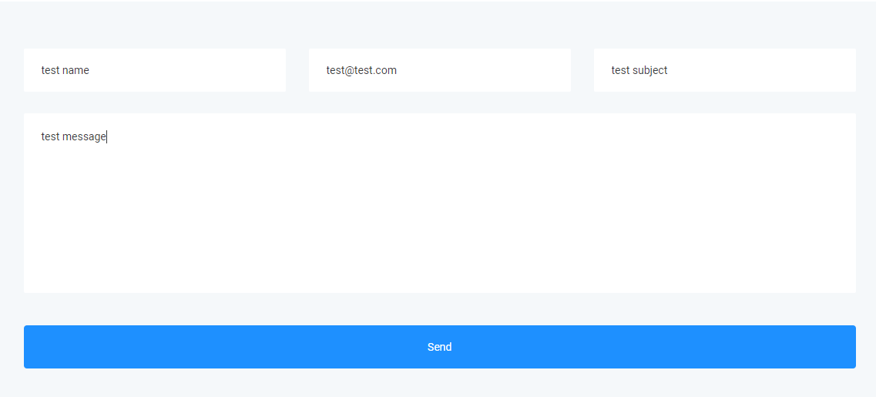

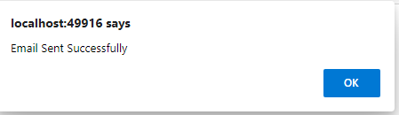

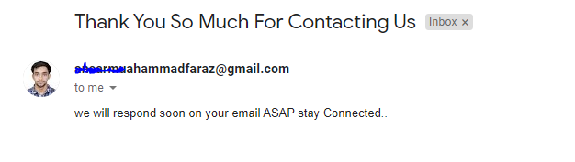

* Test case 002 (testing buyer signup)

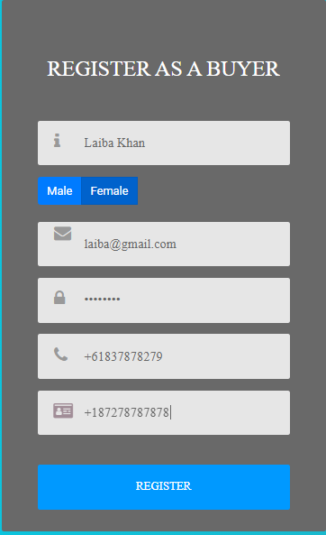

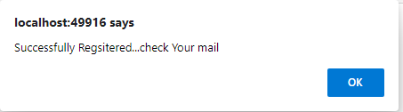

* Test case 003 (testing seller signup)

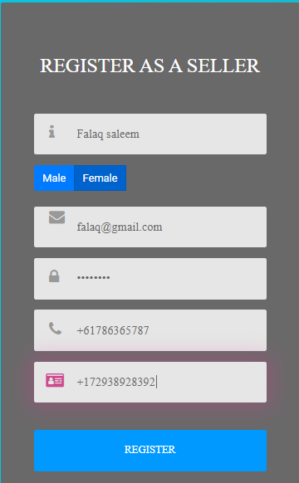

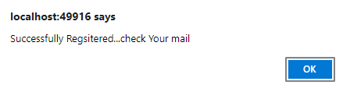



* Test case 004(Login to seller Account)

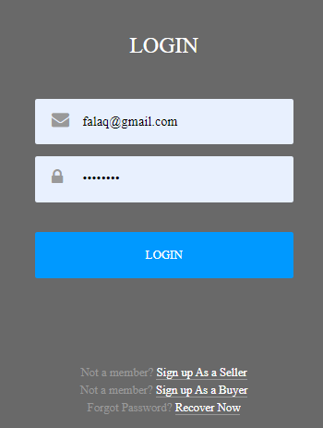

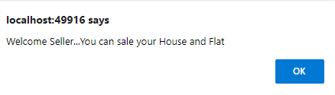

* Test case 005(Navbar Links for Seller)



* Test case 006(Login to Buyer Account)

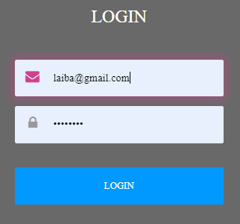

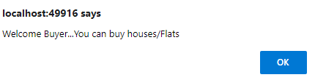

* Test case 007(Navbar Links for Buyer)



* Test case 008(Seller upload property)

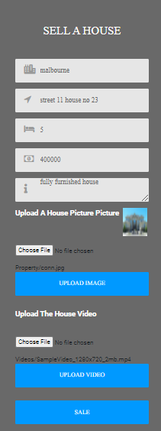

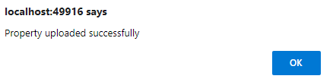



* Test case 009(Property showing on home page)

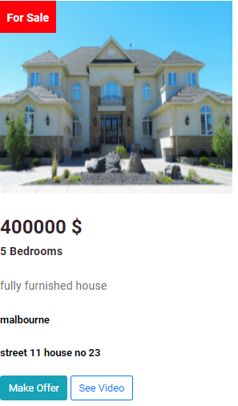

* Test case 010(See Video Button working)

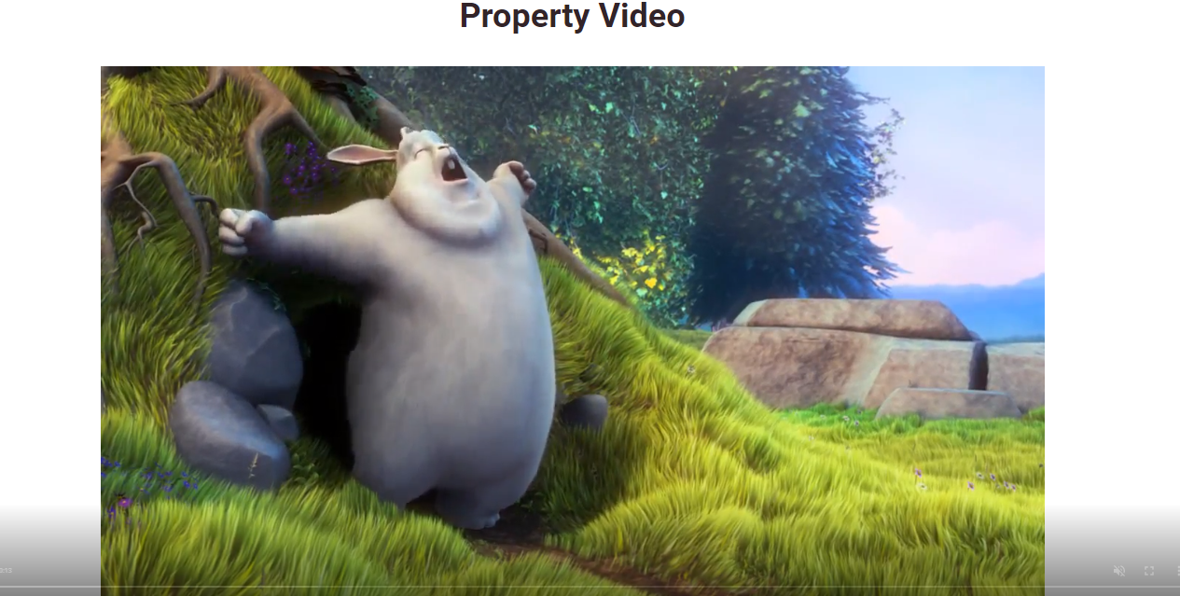

* Test case 011(Seller cannot make offer)

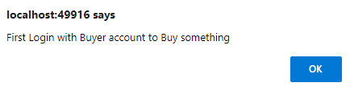

* Test case 012(Buyer can make offer)



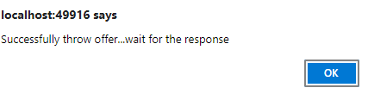

* Test case 013(Buyer can Check its posted bid offer)



* Test case 014(Buyer can delete offer)

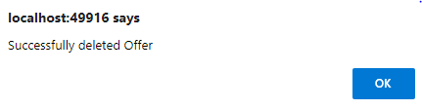

* Test case 015(Buyer can message seller of the property to low the price or anything)

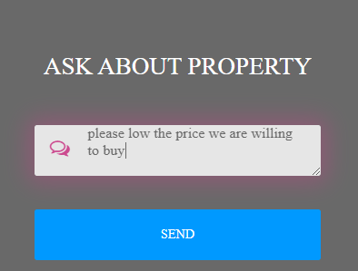

* Test case 016(Seller can check offers to his property)

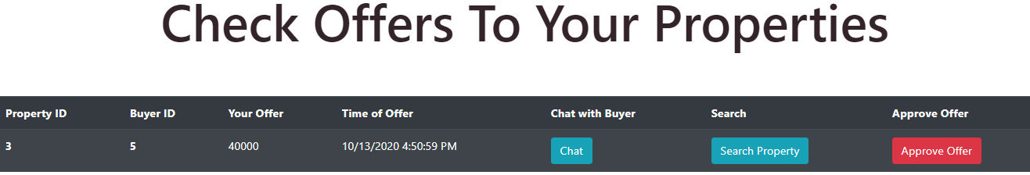

* Test case 017(Seller can check messages to the property by bidder)



* Test case 018(Seller can Approve the offer from biddings)

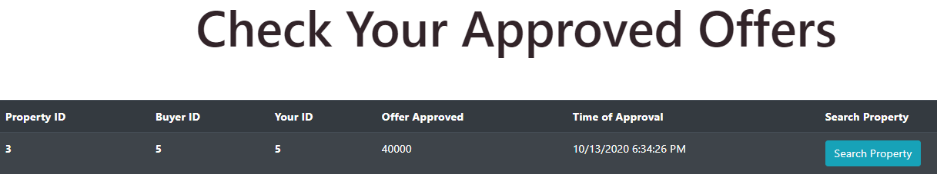

* Test case 019(Buyers can search the property by search filter)

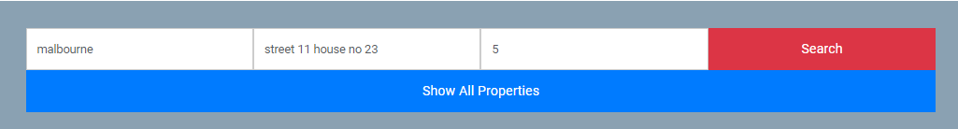

* Test case 020(Property appears by search filter?)

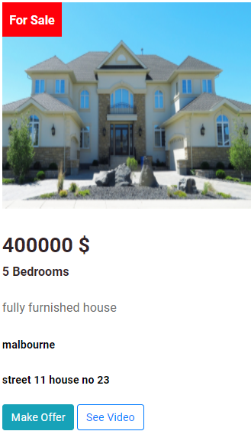

* Test case 021(Map appears in About us page?)

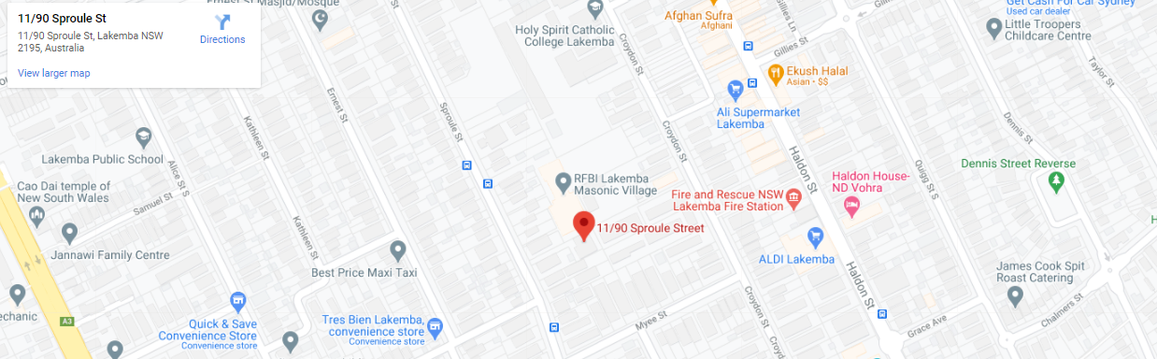

* Test case 022(Admin can Login)

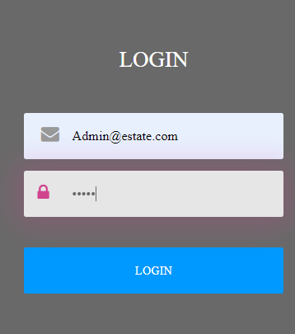

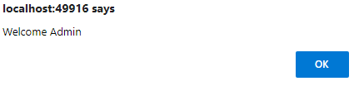

* Test case 023(Admin can see all properties and search for property)

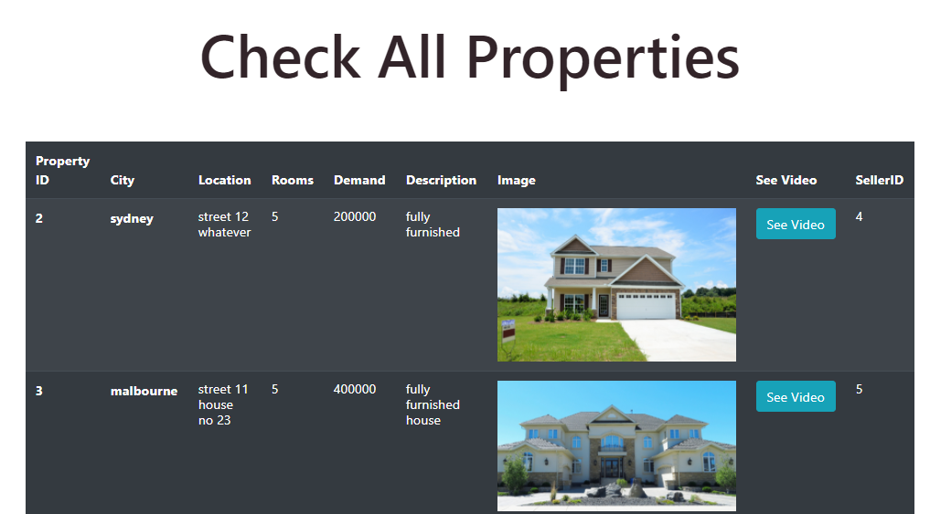





* Test case 024(Admin can Monitor all chats of Users)

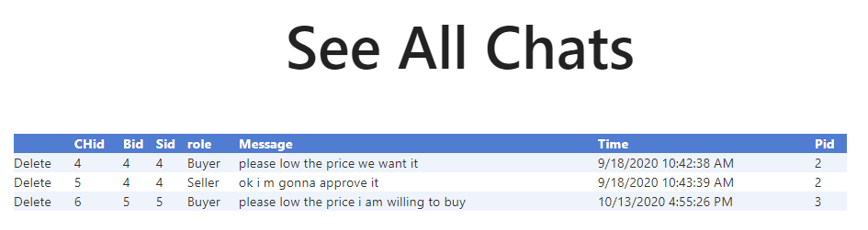

* Test case 025(Admin can Insert another admin)

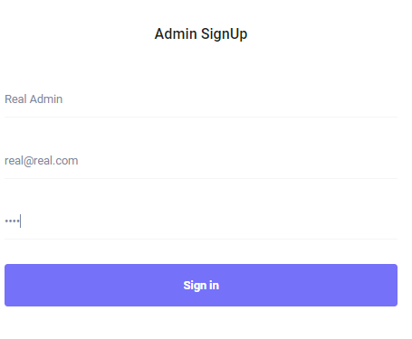

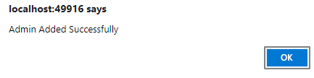

* Test case 026(Admin can Contact buyer and seller)

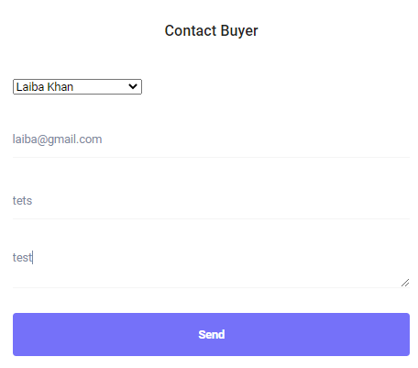

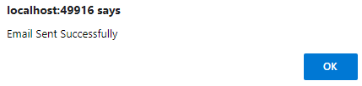

# Test Deliverables

## Overview

we delivered test plan, methodology, test cases and approvals. We already fixed the bugs during development.

## Test Cases

Table ‑ Test Case Table

|  |  |  |  |  |  |
| --- | --- | --- | --- | --- | --- |
| **Test Case Num** | **Description** | **Inputs** | **Expected Output** | **Actual Output** | **Test Result** |
| 001 | Contact form | john ,john@gmail.com ,how to register ,please guide me how to register | Email sent msg | Email sent | pass |
| 002 | Buyer registration | paul ,male ,paul@gmail.com ,paul123 ,+61878328722 ,+1727827823 | Confirmation email | sent | pass |
| 003 | Seller registration | john ,male ,john@gmail.com ,john345 ,+618783823223 ,+187827323288 | Confirmation email | sent | pass |
| 004 | Login | [John@gmail.com , john345](mailto:John@gmail.com%20,%20john345) | Navigate to desired home screen | Not done | fail |
| 025 | Admin registration | Admin, Admin@realestate.com, pass123 | confirmation popup | done | pass |
| 026 | Contact buyer and seller | Select name, property sale, your property has sold in 270000$ | Email sent to person | done | pass |
| 012 | Make Bid | Money offered | Save to database and email sent to sender | done | pass |
| 008 | Property upload | Melbourne , street 11, 27000 , 5, property.jpg, property.mp4 | Email sent to uploader and property uploaded | done | pass |

# Resources and Environment Needs

## Testing Tools

We are using **Manual Testing** for our project because it gives us more efficient system after testing.

## Hardware and Software Requirements for Test Cases

The hardware requirements for the testing and deployment will be:

* Latest PC or Laptop with minimum 2 cores for better performance.
* Minimum 4GB Ram for better performance.
* Mouse and keyboard.
* Internet device.

The software requirements for the testing and deployment will be:

* Visual studio 2017 or latest
* Microsoft SQL Server 2012 or latest
* Strong internet connection.
* Web browser (google chrome recommended)